

UNIVERSITI TENAGA NASIONAL

PUTRAJAYA CAMPUS

SEMESTER 1, YEAR 2024/2025

GROUP ASSIGNMENT

SUBJECT NAME

SUBJECT CODE

SECTION: 01

TOPIC: ”KONGSI RAYA” FROM AN ISLAMIC PERSPECTIVE

PREPARED BY:

|  |  |  |
| --- | --- | --- |
| **NO.** | **STUDENT ID** | **FULL NAME** |
| 1 | BSW01084329 | ABDULLAH MUJADDID ADLI BIN ABDUL HALIM |
| 2 | BSW01085195 | GHALEB NASSAR SULTAN AHMED |
| 3 | YOUR ID | YOUR NAME |

LECTURER’S NAME: ______________________

**TABLE OF CONTENT**

| CONTENTS | PAGES |
| --- | --- |
| 1.0 Abstract | 1 |
| 2.0 Introduction  2.1 Background of The Topic  2.2 Definition  2.3 Objectives of The Study | 2 - 3 |
| 3.0 Literature Review | 4-5 |
| 4.0 Methodology    4.1 Case Study Analysis  4.2 Expert Interviews  4.3 Content Analysis | 6 |
| 5.0 Result and Analysis  5.1 Islamic Concerns Regarding “Kongsi Raya”  5.2 Social Benefits of “Kongsi Raya”  5.3 Divergent Views Among Scholars  5.4 Impact on Religious Identity | 7 |
| 6.0 Conclusion | 8 |
| 7.0 References | 9 |
| 8.0 Appendix | 10-15 |

**1.0 Abstract**

This research focuses on the idea of Kongsi Raya based on the Islamic paradigm as well as its practicality to promote social integration in Malaysian multi-ethnic communities. The multicultural population in Malaysia is reflected in the increasingly common "Kongsi Raya" celebration, which involves sharing and coming together to celebrate the two significant cultural holidays, Chinese New Year and Hari Raya Aidilfitri. The practice's conformity with Islamic teachings regarding participation in non-Islamic religious festivities, however, is a matter of grave concern. From an Islamic perspective, concerns are raised regarding akidah (faith), hukum (law), and shariah (Islamic jurisprudence) because these factors influence the extent to which Muslims can observe festivals that are not associated with their own faith.

The purpose of this study is to examine how Islamic scholars view "Kongsi Raya" by discussing the circumstances in which Muslims might take part in such celebrations without sacrificing their religious identity. The study aims to give Muslim communities advice on how to handle ecumenical holidays while upholding Islamic principles by citing the Quran, Hadith, and academic fatwas.

The findings indicate that "Kongsi Raya" has the ability to foster tolerance, respect for one another, and cross-cultural understanding when observed carefully and in accordance with Islamic principles. Communities can develop a greater knowledge of cultural variety by participating in one another's festivities, which will improve social relationships and lessen miscommunications. When handled with tact, these festivities enable Muslims to participate without sacrificing their religious beliefs. As a result, "Kongsi Raya" can promote Malaysia's goal of inclusivity and togetherness by fostering a peaceful society where many communities coexist.

1

**2.0 Introduction**

**2.1 Background of The Topic**

Kongsi Raya is a concept that arises from a context of plural society in Malaysia, which refers to simultaneous celebrations of festivals from different religions and races, like Hari Raya Aidilfitri and Chinese New Year. This tradition became a symbol for unity and harmony among different ethnic in Malaysia, thus encouraging a spirit of tolerance and also understanding amongst cultures. Behind the spirit of this goodwill, the issue about Kongsi Raya has been the subject of discussion among Islamic scholars and the general public, especially in evaluating to what extent this concept is in line with Islamic teachings.

From the perspective of Islam religion, concerns arise from hukum, akidah and limitations that need to be obeyed for Muslims to get involved with other religions festivals. Islamic approaches to this issue need to have a deep understanding about akidah, shariah and concept of tolerance in Islam which will be different from context and interpretation in one mazhab to another. This case study is intended to dissect the issue of Kongsi Raya from the perspective of Islam by referring to perspectives from Islamic scholars, fatwa and Al-Quran along with Hadith.

Therefore, this case study is important to understand how far Kongsi Raya can be accepted by Muslims, while preserving the spirit of national unity that has been the foundation of social harmony in Malaysia. This case study also intended to give guidelines for Islamic communities in living daily life with multiple races with harmony without disobeying the principles of iman and shariah.

**2.2 Definition**

Kongsi Raya refers to the joint celebration of festivals that happens when two main festivals in plural society in Malaysia happen and are welcomed simultaneously or that are near one another in a calendar. This term is often used to describe joint celebration of Hari Raya Aidilfitri and Chinese New Year which involves activities like open house, feast gathering and cultural exchange with Malay community and Chinese community in Malaysia.

Kongsi Raya doesn't have to refer to actual physical joint festivals but also as a symbol for harmony, understanding and tolerance between cultures and races that's been the foundation to national unity. However, in Islamic context, Kongsi Raya also causes issues and debates about the limitations of akidah, especially about how far and deep can Muslims be involved in celebration of other religions festivals without breaking the principles in iman and hukum syarak.

2

**2.3 Objectives of The Study**

The main objectives of the study are:

* To analyze Islamic perspective on Kongsi Raya including principles of shariah and akidah that's related to the participation of Muslims in other religions festivals.
* To study the role of Kongsi Raya in promoting harmony and unity in all races in Malaysia as well as how these values can be understood and integrated in the context of Muslims.
* To elaborate Kongsi Raya social impact against religious identity and Muslim society in Malaysia as well as how Kongsi Raya can be implemented without affecting akidah in Islam.

3

**3.0 Literature Review**

Referring to the appendix, this case study discusses Islamic perspective on Kongsi Raya while referring to many opinions and arguments from Islamic scholars as well as Islamic institutions in Malaysia. Articles and fatwas that has been out by the authorities play an important role in understanding this issue in Islamic perspective.

1. The Origin of Kongsi Raya in Malaysia

Kongsi Raya refers to a practice of celebrating religious and cultural festivals simultaneously in Malaysia. This practice first started a few years back when big festivals like Hari Raya Aidilfitri and Chinese New Year were always on the same day or week in a calendar. Therefore, this approach was used to nurture harmony and unity between races in Malaysia. This approach was also adopted by many government agencies and statutory bodies as a symbol of national integration.

1. The Position of Kongsi Raya in Islamic Perspective

In Islamic context, there are a lot of questions that arise about the validity of Kongsi Raya from hukum syarak. This issue got serious when Jabatan Mufti Negeri Perak, from Mufti Datuk Seri Harussani Zakaria, made a fatwa on 22 October 2003 that said combining Islamic festivals with festivals from other religions is Haram and prohibited. This fatwa is based on the threat towards pluralism in religion, which can cause confusion on the truth of Islam as a one and only true religion. Mufti Perak insisted that this practice can damage the akidah of a Muslim because it is as if validating the victory of other religions.

1. The danger of pluralism and Issue About Tasyabbuh (assimilation of Kafir)

The opinion about Kongsi Raya mirroring the danger of pluralism was also debated by Islamic scholars. The Pluralisme concept which equates all religion is against with Islam beliefs that insist Allah is only one and only God and the superiority of Islam. Mufti Perak expressed his concern that by validating Kongsi Raya can cause delirium in akidah. The prophet Muhammad SAW prohibited his ummah to imitate Kafir actions and practices becoming the important argument that strictly indicates an action that imitate Kafir is against Islam beliefs. This issue is emphasized in hadith sahih that state whoever that imitates actions and practices of Kafir, then he is part of that group.

1. Response and Debate In The Intellectual Group

The views expressed by the Mufti of Perak received reactions from various parties, including intellectuals such as Dr. Chandra Muzaffar. Dr. Chandra asked for further clarification on the concept of pluralism that was raised, pointing out that there is confusion or a difference of understanding about the true meaning of pluralism in the context of Islam. This debate reflects the difference of opinion between scholars and scholars in understanding the issue of Kongsi Raya.

1. Argument in Al-Quran and Hadith About Prohibition on Celebrating Other Religions Festivals

The proofs of the Quran and hadith are also the main reference in understanding this issue. The word of God in surah at-Taubah [9:33] and al-Fath [48:28] confirms that Islam is the true religion and must be won over other religions. The interpretation of scholars such as Ibn Kathir reinforces the argument that any form of respect or recognition of other religious festivals can be considered as belittling the superiority of Islam. The hadith which states that acting like the infidels will cause a person included in their group to be used as a backup in prohibiting Muslims from celebrating Kongsi Raya. 4

1. Approaches In Fiqh Methodology on Determining Hukum.

In determining Islamic law, the fiqh method is the main guide. Scholars insist that all the actions of Muslims must be bound by Islamic law, and real benefits will only exist if Islamic law is fully applied. The Prophet's hadith that mentions the clarity of halal and haram shows that Muslims need to be careful in avoiding dubious matters that may threaten their faith.

This literature shows that Kongsi Raya, although seen as an effort to strengthen unity, raises big questions from an Islamic perspective that requires further study to understand its legal and social implications in Muslim society.

5

**4.0 Methodology**

This study uses a qualitative approach to explore the Islamic perspective on the concept of “Kongsi Raya” in Malaysia. The methodology involves the following key steps:

**4.1 Case Study Analysis**

A case study approach is employed to examine specific instances of “Kongsi Raya” celebrations in Malaysia. The analysis focuses on how these joint celebrations were conducted, their impact on Muslim communities, and the extent of Muslim participation. The case studies provide practical examples and highlight the complexities involved in balancing cultural integration with religious obligations.

**4.2 Expert Interviews**

The study incorporates insights from interviews with Islamic scholars, religious leaders, and experts in comparative religion. These interviews aim to gather diverse perspectives on the issue, particularly on the interpretation of Islamic law (Shariah) and its application in a multicultural context. The interviews help understand different viewpoints and the reasoning behind the various rulings on “Kongsi Raya.”

**4.3 Content Analysis**

A content analysis of relevant fatwas and religious discourses is performed to identify key themes and arguments regarding the permissibility of “Kongsi Raya.” The analysis focuses on recurring concerns such as issues of faith (akidah), legal rulings (hukum), and the risk of religious pluralism. This approach helps in synthesizing different scholarly opinions and forming a comprehensive understanding.

6

**5.0 Result and Analysis**

The findings of the study highlight the following aspects:

**5.1 Islamic Concerns Regarding “Kongsi Raya”**

The analysis reveals significant concerns among Islamic scholars regarding the celebration of “Kongsi Raya.” The primary issue is the potential threat to Muslim faith (akidah) when participating in non-Islamic religious festivities. Scholars argue that combining Islamic celebrations with those of other religions may inadvertently validate or show acceptance of other faiths, which is seen as contrary to the principles of Islamic monotheism.

**5.2 Social Benefits of “Kongsi Raya”**

Despite religious concerns, the study finds that “Kongsi Raya” has potential social benefits, particularly in fostering unity and harmony among Malaysia’s multi-ethnic population. The joint celebration of Chinese New Year and Hari Raya Aidilfitri serves as a symbol of national integration, promoting mutual respect and understanding between different cultural and religious communities. When conducted within the bounds of Islamic guidelines, these celebrations can enhance social cohesion without compromising religious identity.

**5.3 Divergent Views Among Scholars**

The study uncovers differing opinions among Islamic scholars and intellectuals regarding the permissibility of “Kongsi Raya.” While some scholars, such as those from the Jabatan Mufti Negeri Perak, have issued strict fatwas against it, others like Dr. Chandra Muzaffar call for a nuanced interpretation of pluralism in the context of Malaysia’s unique cultural landscape. The divergent views highlight the need for a balanced approach that considers both religious principles and the importance of social integration.

**5.4 Impact on Religious Identity**

The analysis indicates that “Kongsi Raya,” if not carefully managed, can pose a risk to the religious identity of Muslim participants. There is a concern that Muslims, especially younger generations, may become confused about the distinctiveness of their religious practices when participating in joint celebrations. The study emphasizes the importance of educating the Muslim community about the boundaries of participation in non-Islamic festivities to safeguard their faith while still engaging in cultural exchanges.

7

**6.0 Conclusion**

The concept of “Kongsi Raya,” while aimed at fostering unity and harmony in Malaysia’s multicultural society, presents a complex issue from an Islamic perspective. On one hand, it serves as a symbol of national integration, allowing diverse communities to come together, share cultural practices, and build mutual understanding. This aligns with the broader goals of social cohesion and inclusivity that are vital for a pluralistic nation like Malaysia.

However, from a religious standpoint, the celebration of “Kongsi Raya” raises significant concerns regarding Islamic teachings on faith (akidah), religious law (hukum), and the potential risks of religious pluralism. Islamic scholars caution that joint celebrations with non-Islamic religious festivals may blur the lines of religious identity and could inadvertently validate the practices of other faiths, which is contrary to the principles of Islamic monotheism.

The differing opinions among Islamic scholars reflect the broader debate on how to balance cultural integration with religious obligations. While some scholars strictly prohibit participation, others advocate for a more contextual understanding that takes into account Malaysia’s unique socio-cultural landscape.

In conclusion, “Kongsi Raya” can contribute positively to social harmony and the spirit of togetherness if observed with clear guidelines that respect Islamic principles. It requires a careful approach that emphasizes education and dialogue within the Muslim community to ensure that participation in such celebrations does not compromise religious beliefs. Ultimately, the practice can be a valuable tool for promoting unity, provided it is done with sensitivity to Islamic teachings and the preservation of religious identity.

8

**References**

1. Malaysia, H. T., & Malaysia, H. T. (2017, December 16). Kongsi Raya – keharamannya jelas. Hizbut Tahrir Malaysia. <https://mykhilafah.com/kongsi-raya-keharamannya-jelas-3/>
2. Sahaja, M. (2008, January 29). Kongsi Raya open houses pointless. Malaysiakini. https://m.malaysiakini.com/letters/52866
3. Contributors to Wikimedia projects. (2022, October 10). Kongsi Raya. Wikipedia Bahasa Melayu, Ensiklopedia Bebas. https://ms.m.wikipedia.org/wiki/Kongsi_Raya

9

**Appendix**

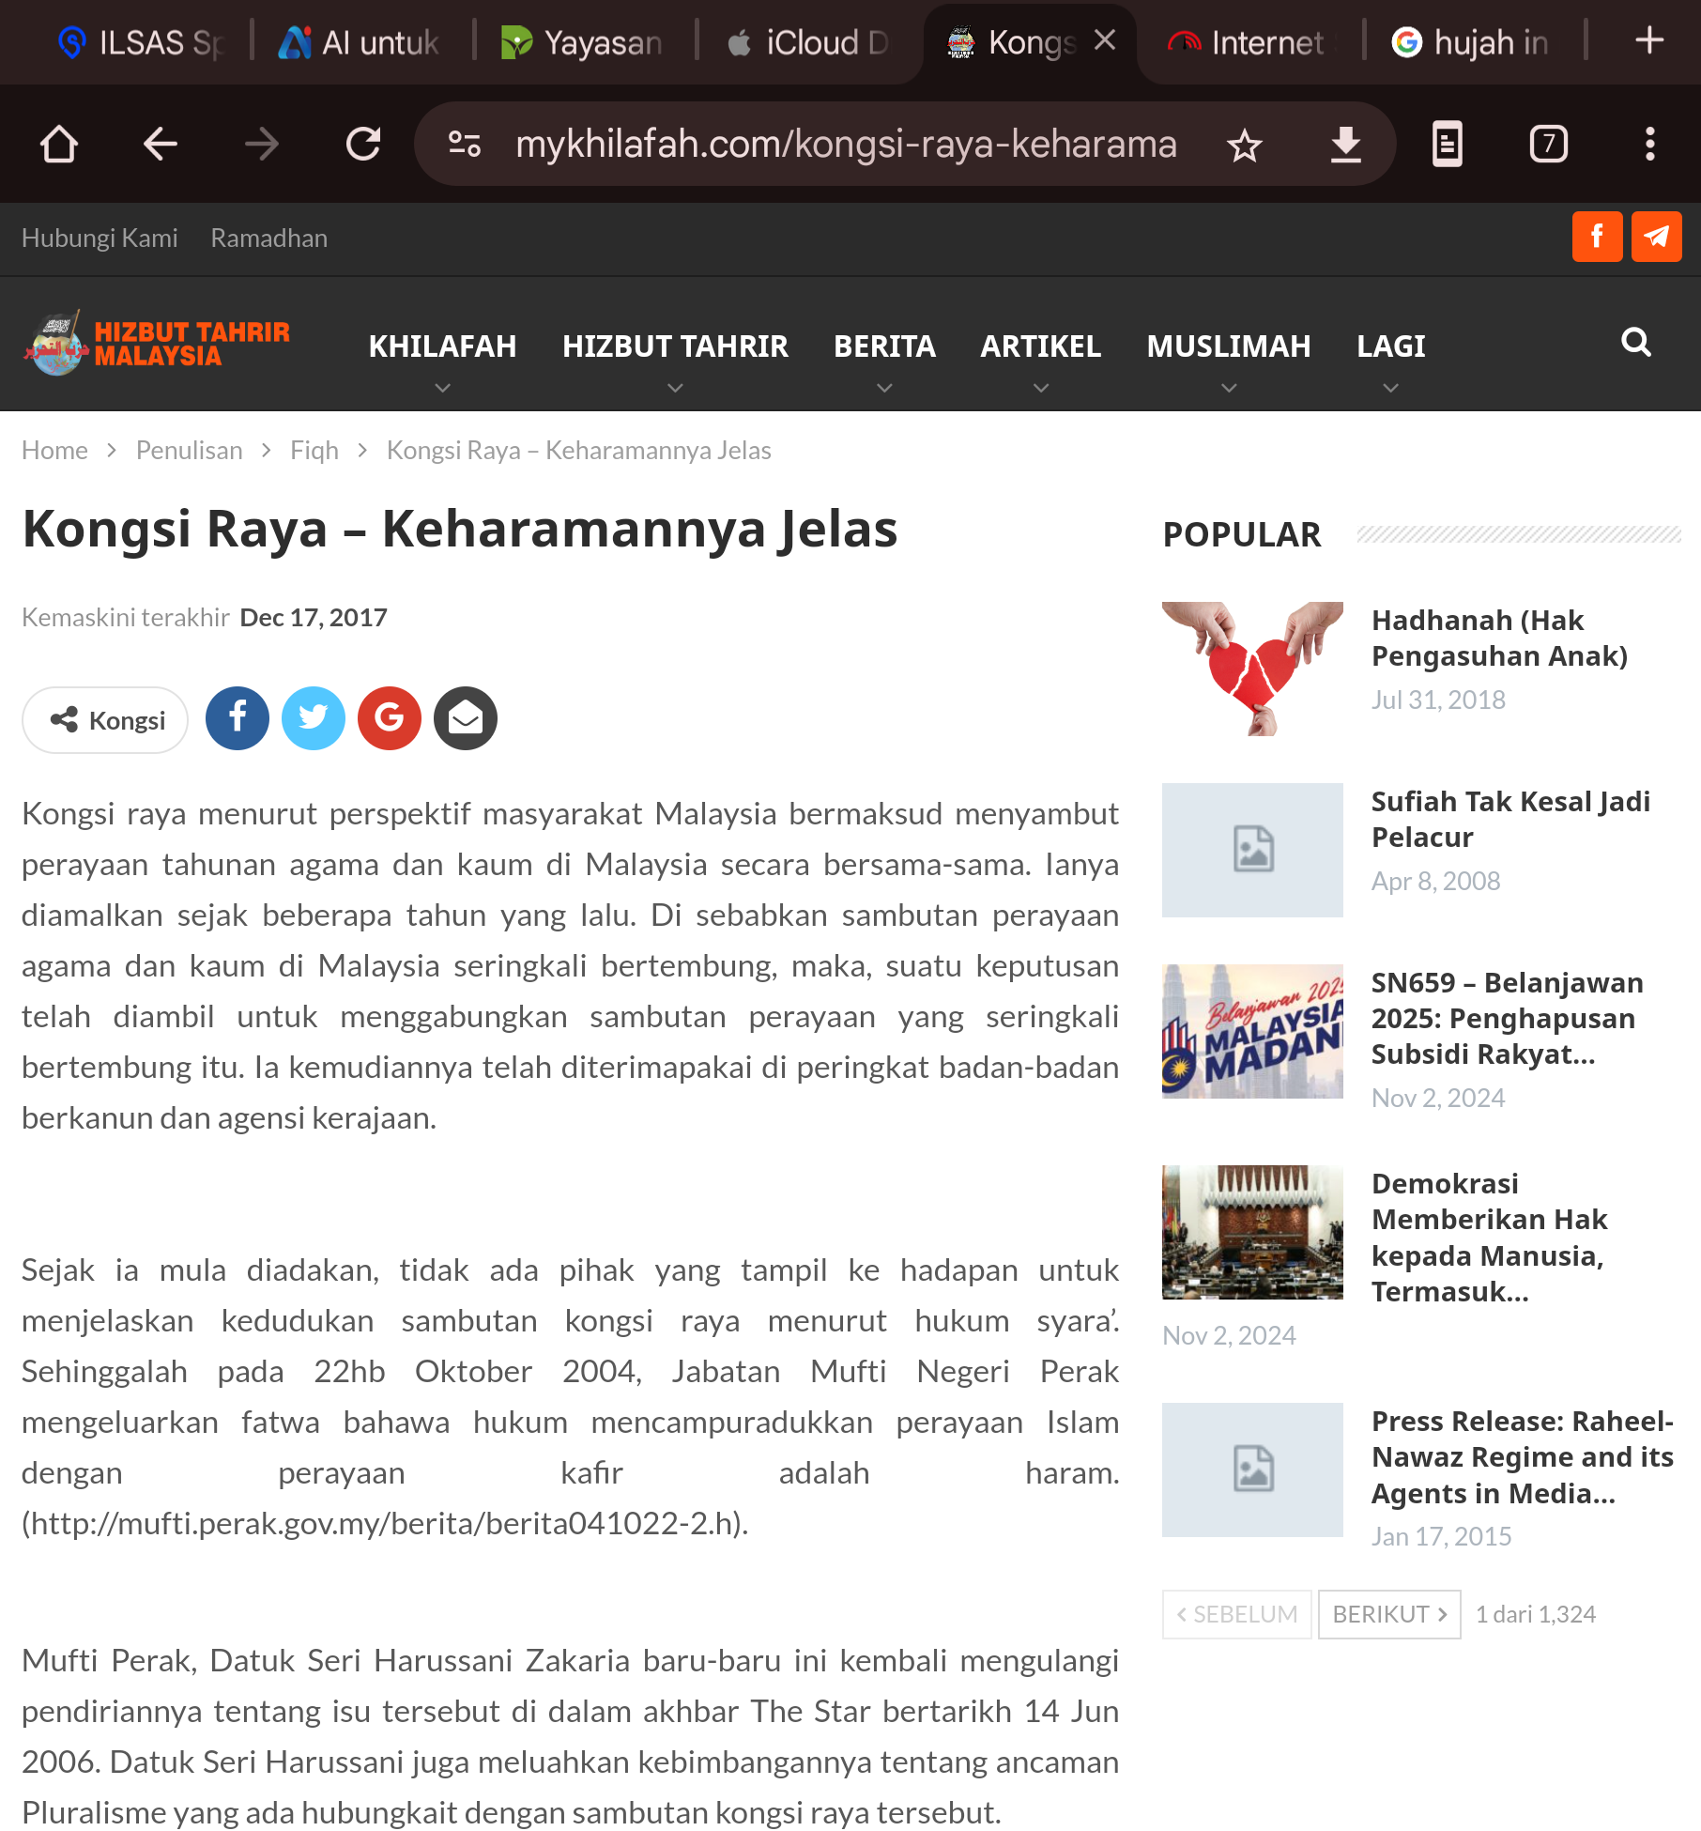

10

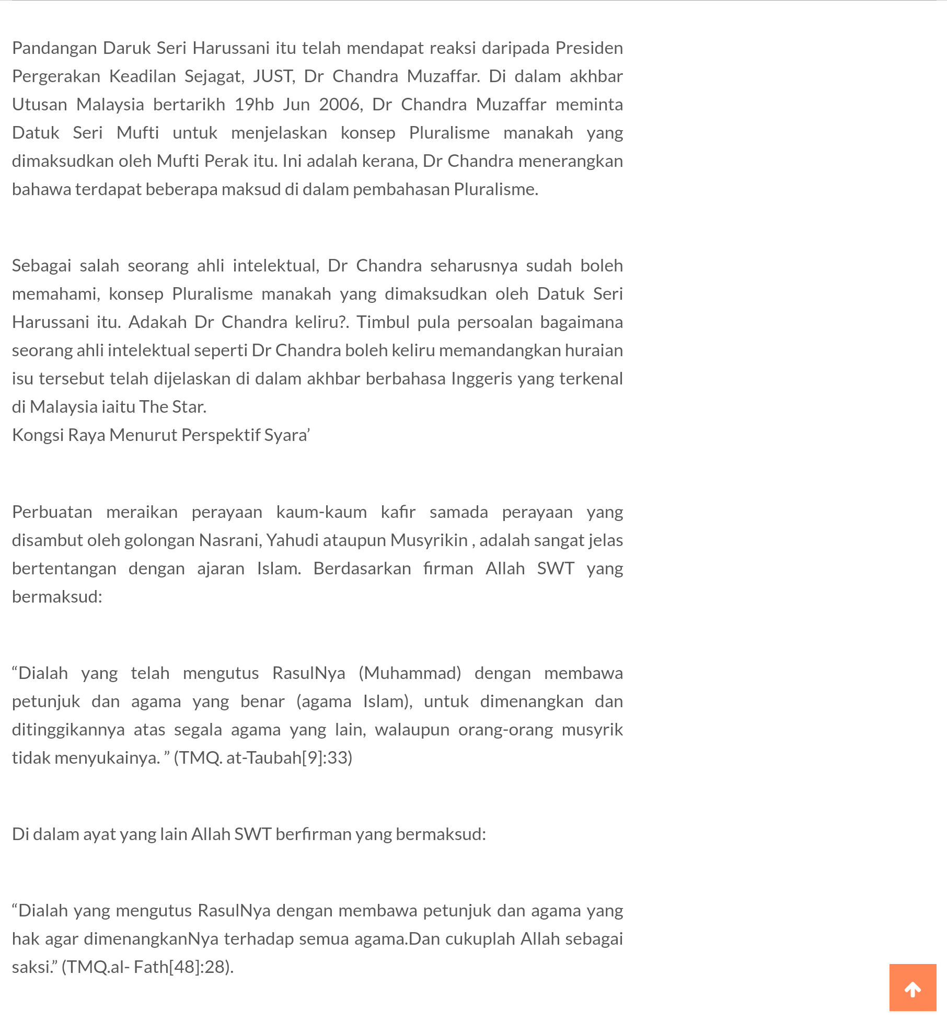

11

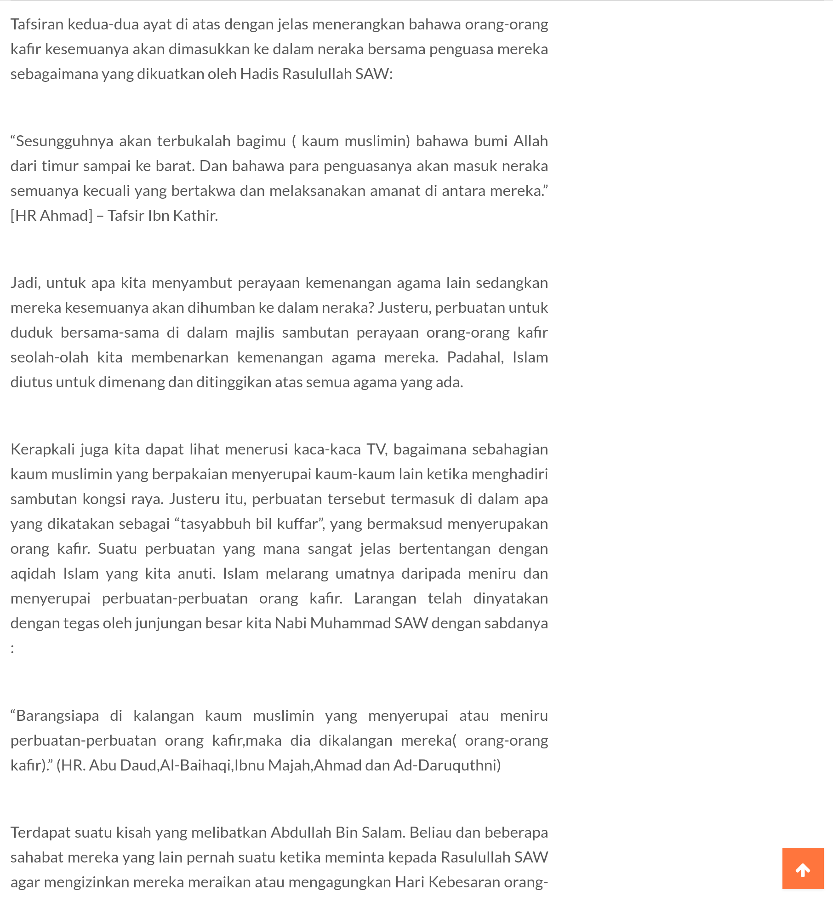

12

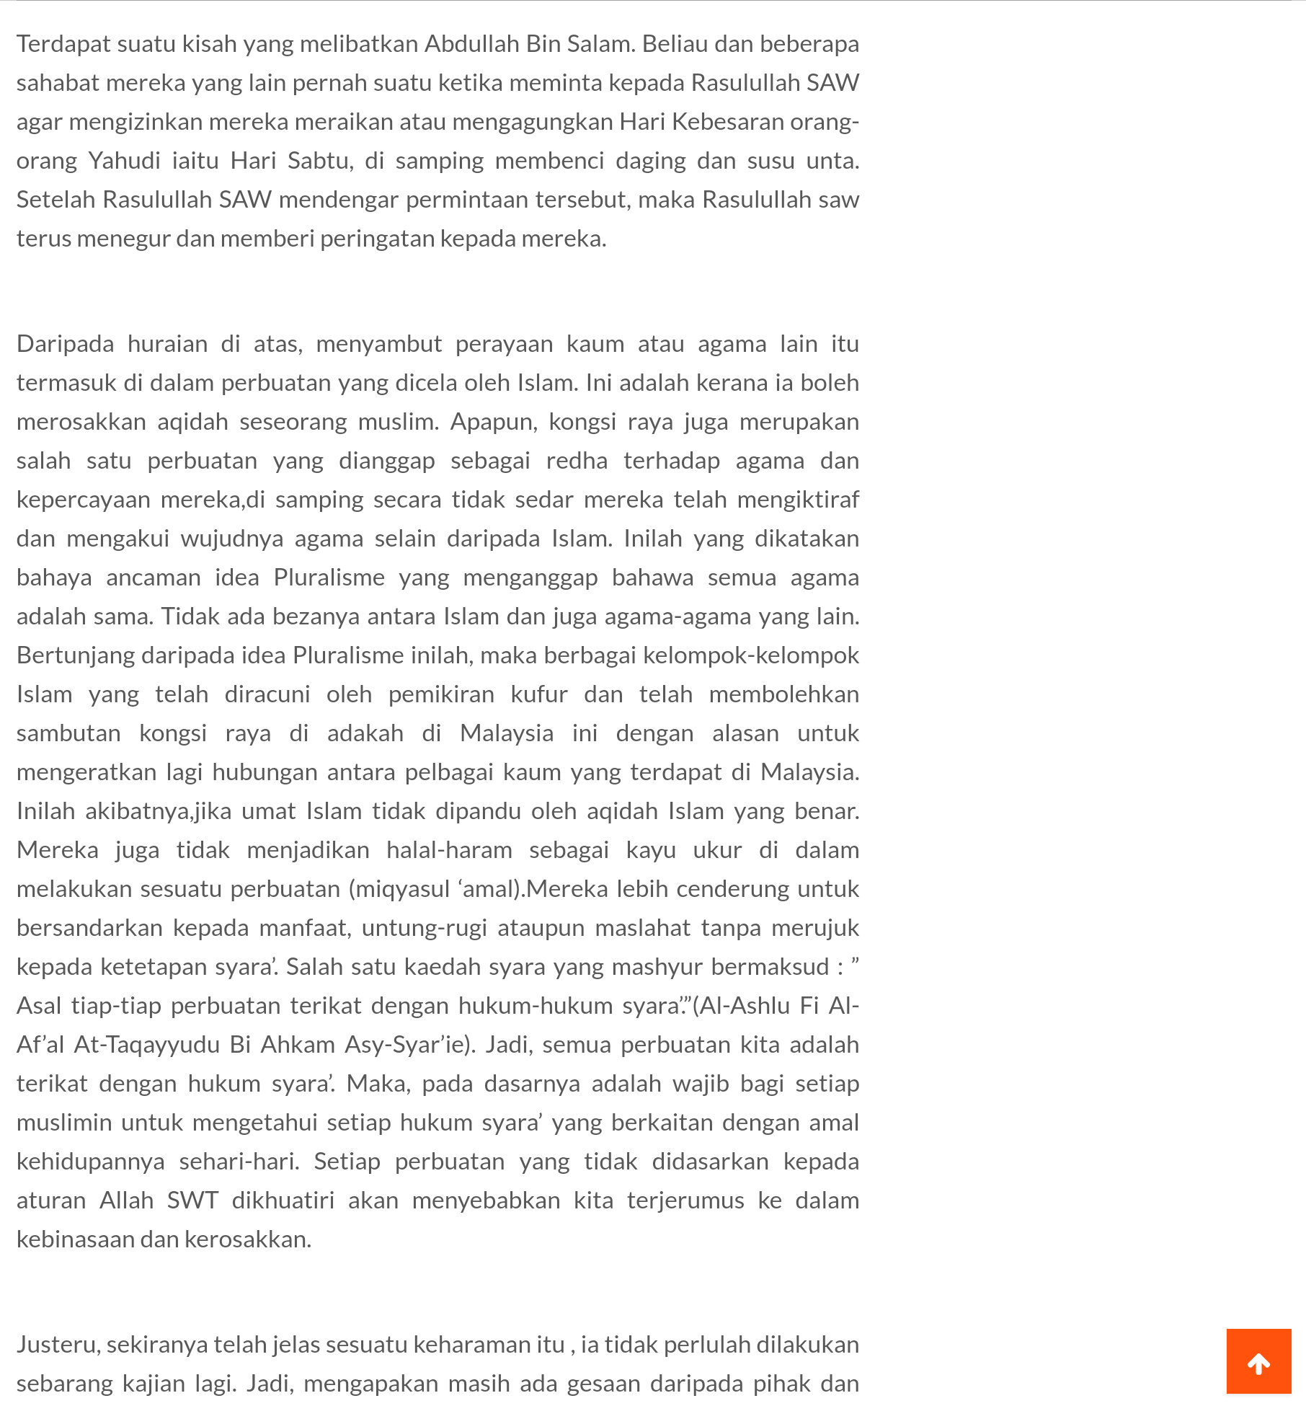

13

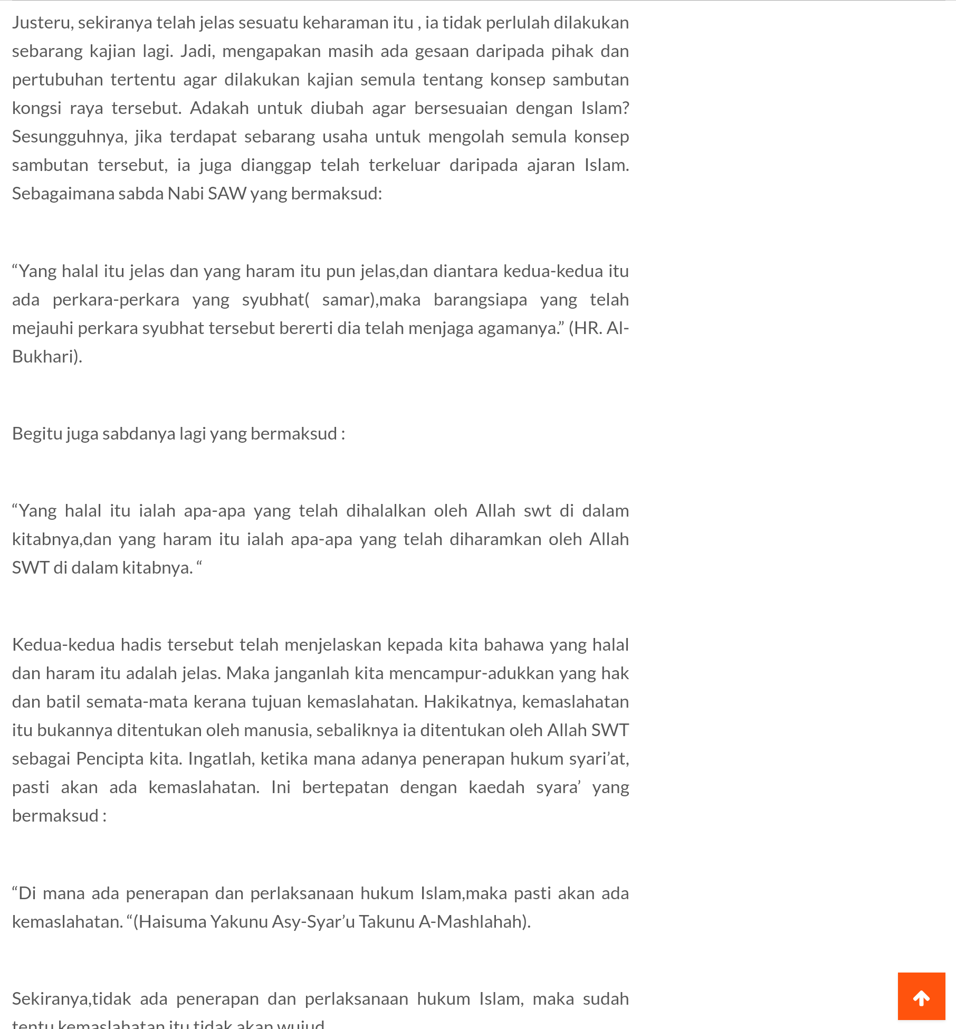

14

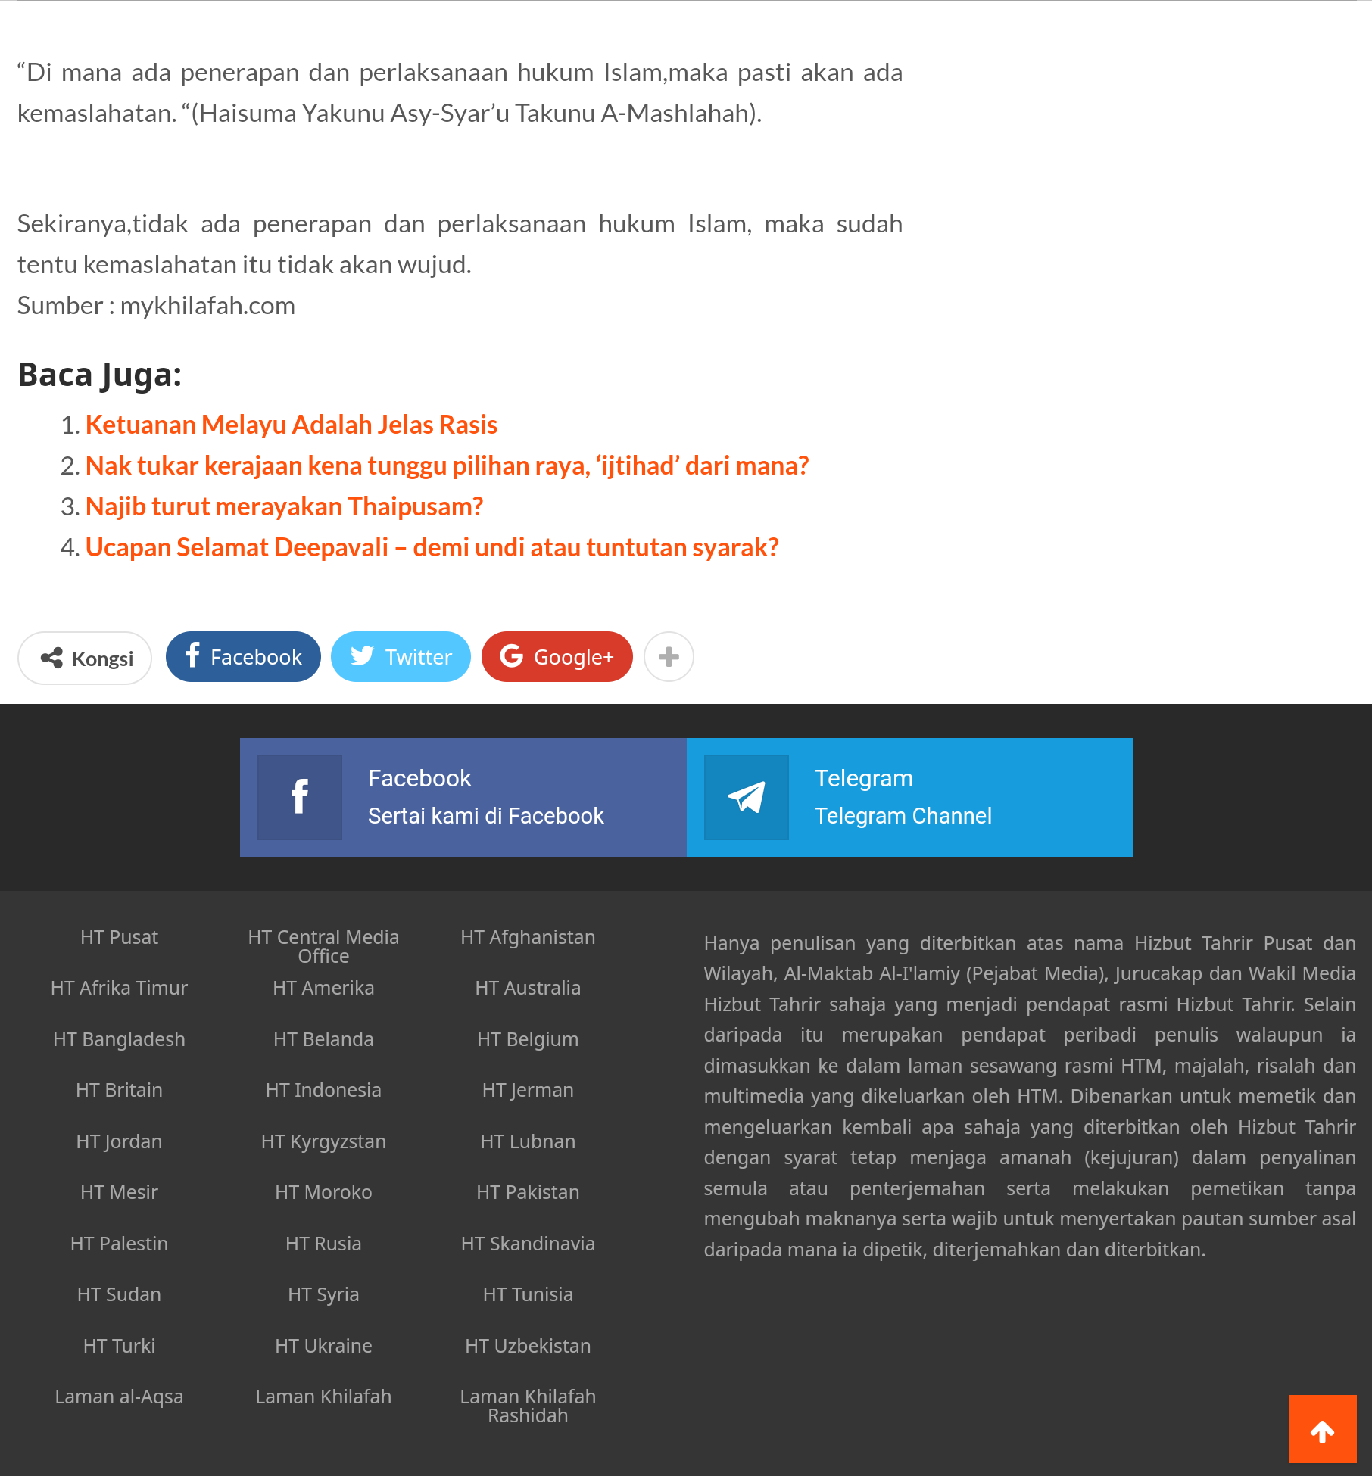

15